AcademiaCLI: A Python Console-Based Student Information System (SIS)
---------------------------------------------------------------------

Introduction to Computing Project
Presented to the
Faculty of the College of Information Technology
Cagayan de Oro College
Cagayan de Oro City

-------------------------------------------------------------------------------

In Partial Fulfillment
of the Requirements for the Degree
Bachelor of Science in Information Technology

-------------------------------------------------------------------------------

NAME OF RESEARCHER

JUNDIT, RAMIL G. JR.
LOOR, MICHAEL JOHN P.
EDROLIN, LOREN JEAN B.
LAPLANA, MHELJAYSON A.

OCTOBER 2026

  - Introduction
Student information management is an essential part of educational institutions because it involves organizing, accessing, updating, and maintaining student records. A Student Information System can help educational institutions manage student data more efficiently and make information easier to access. Gomathy et al. (2022) explained that student information systems are designed to manage student data and activities in educational establishments, particularly in situations where manual processes can be time-consuming. Similarly, Çelik and Ayaz (2022) examined the validity of the DeLone and McLean Information Systems Success Model in the context of student information systems, emphasizing the importance of evaluating information system success.

The intended users are first-year Bachelor of Science in Information Technology students and instructors under the College of Information Technology Education Department at PHINMA Cagayan de Oro College. In the current operational setting, student documents are handled manually by recording and organizing information in paper forms, folders, and physical files where teachers or staff must manually search, update, and remove records. Within this manual workflow, three primary problems emerge: first, personnel experience difficulty organizing basic student information such as Student ID, name, birthdate, course, year level, and section when records are not properly arranged; second, it takes additional time searching and accessing specific student records manually; and third, staff encounter difficulty updating and managing student information when changes must be handled by hand (Riño & Daing, 2022; Cenezan & Gacusan, 2025).

The proponents—Bachelor of Science in Information Technology students under the College of Information Technology Education Department at PHINMA Cagayan de Oro College—developed AcademiaCLI: A Python Console-Based Student Information System (SIS), a Python console-based application designed to address the identified problems. The system is utilized by first-year BSIT students and instructors. The application allows students to create accounts, log in, add basic details, view records, and update their names, while allowing instructors to select preconfigured accounts, view section records, search using Student IDs, and delete entries. These implemented functions resolve the three problems by organizing basic student records into structured digital formats (Problem 1), enabling rapid ID-based searching (Problem 2), and streamlining record updating and maintenance (Problem 3).

  - Statement of the Problem
General Problem
First-year Bachelor of Science in Information Technology students and instructors under the College of Information Technology Education Department at PHINMA Cagayan de Oro College encounter significant administrative delays and tracking challenges when managing student records through manual paper forms and physical files. This manual workflow affects users because unorganized records are hard to navigate, manual searching consumes valuable time, and handling updates by hand leads to record management inefficiencies.

Specific Problems
- Difficulty in organizing basic student information – Personnel experience difficulty arranging basic student details (Student ID, name, birthdate, course, year level, section) properly when tracked through manual physical files, leading to disorganized records.
- Additional time searching and accessing records – Searching for and retrieving specific student records manually takes extra time and delays academic administrative tasks and record verification.
- Difficulty in updating and managing student information – Handling changes, updates, and record removals manually makes maintaining accurate student information cumbersome and prone to oversight.

  - Objectives of the Study
General Objective
To develop AcademiaCLI: A Python Console-Based Student Information System (SIS), a Python console-based application that enables first-year Bachelor of Science in Information Technology students and instructors under the College of Information Technology Education Department at PHINMA Cagayan de Oro College to record, store, search, and manage basic student information efficiently.

Specific Objectives
The project specifically aims to:
- To develop a function that allows students to input, record, and store basic student details (Student ID, name, birthdate, course, year level, and section) into structured digital storage, directly addressing the difficulty in organizing basic student information.
- To implement a search function that enables instructors to quickly search for and retrieve specific student records using their Student ID, directly addressing the additional time required for searching and accessing records.
- To provide functions that allow students to update their names and enable instructors to manage records by deleting unwanted entries using Student IDs, directly addressing the difficulty in updating and managing student information.

  - Scope
This project covers the development of AcademiaCLI: A Python Console-Based Student Information System (SIS), a Python console-based application intended for first-year Bachelor of Science in Information Technology students and instructors. The system will operate in the College of Information Technology Education Department at PHINMA Cagayan de Oro College and will use temporary in-memory Python dictionaries and lists for storing the required data during program execution.

The project includes the following:
- Student Account and Record Management – Allows students to create accounts, log in securely using credentials, add basic student profile details, view their stored information, and update their names, producing verified profile entries.
- Instructor Section Viewing and ID Search – Allows instructors to select preconfigured teacher profiles, view student records organized by section, and instantly search for specific student records using their Student ID.
- Student Record Deletion and Maintenance – Enables instructors to manage and remove outdated or unwanted student records by entering the respective Student ID.
- Data Covered – Processes, displays, and temporarily stores Student IDs, student names, birthdates, courses, year levels, sections, account usernames, and passwords in program memory.

The project is limited to the processes and functions implemented by the proponents during the development period.

  - Limitations
The proposed system has the following limitations:
- The system is console-based and does not provide a graphical user interface or web-based interface.
- The system is designed for first-year Bachelor of Science in Information Technology students and instructors under the College of Information Technology Education Department at PHINMA Cagayan de Oro College and does not provide access for users outside the intended setting.
- Data storage is limited to temporary in-memory Python dictionaries and lists while the program is running, and the system does not use a centralized online database unless implemented.
- The system does not support simultaneous access by multiple users.
- The system does not provide real-time notifications, email notifications, or SMS notifications unless these functions are actually implemented.
- System security is limited to the authentication and validation features actually implemented by the proponents.

  - System Requirements
Hardware Requirements
The system requires the following hardware:
- A computer or laptop with a dual-core processor or equivalent.
- At least 4 GB of RAM.
- At least 500 MB of available storage for the application and students’ records.
- Keyboard and monitor/display.

Software Requirements
The system requires:
- Operating System: Windows 11 and Windows 10
- Python Version: Python 3.14
- Development Environment: Visual Studio Code
- Required Libraries/Packages: Python Standard Library Modules only(No third-party packages required)
- Storage: Temporary in-memory Python dictionaries and lists.

Functional Requirements
The system shall allow Students to:
- Create an account by entering a Student ID, username, and password, after which the system records and validates the credentials.
- Log in by entering a valid Student ID, username, and passwords, after which the system authenticates credentials and grants to the student menu.
- Add basic information by entering name, birthdate, course, year level, and section, after which the system stores the profile entries in program memory.
- View student information to inspect stored personal profile records.
- Update name by entering a new name, after which the system updates the student record.
- Log out to return to the main application menu.
The system shall allow the Teacher/Instructor to:
- Select a teacher profile by choosing a preconfigured name from the teacher menu, after which the system grants access to the teacher interface.
- View student information to inspect records organized by section.
- Search for a specific student by entering the Student ID, after which the system retrieves and displays the matching student record.
- Delete a student record by entering the Student ID, after which the system removes the entry from the active memory.
- Log out to return to the main application menu.

The system shall also:
- Receive appropriate validation when invalid information, empty fields, or non-existent Student IDs are entered, displaying a clearer error prompt or not-found message.

  - Code Snippet of AcademiaCLI: A Python Console-Based Student Information System (SIS)
This section presents the main features of AcademiaCLI: Student Information System, a console-based program developed using Python. The system is designed to help students access their information and allow teachers to add and manage student records. The screenshot below shows the main program and its menu, followed by selected code snippets that demonstrate the system’s main features. Each code snippet includes its related objective and purpose to explain how it contributes to the overall functionality of the system.

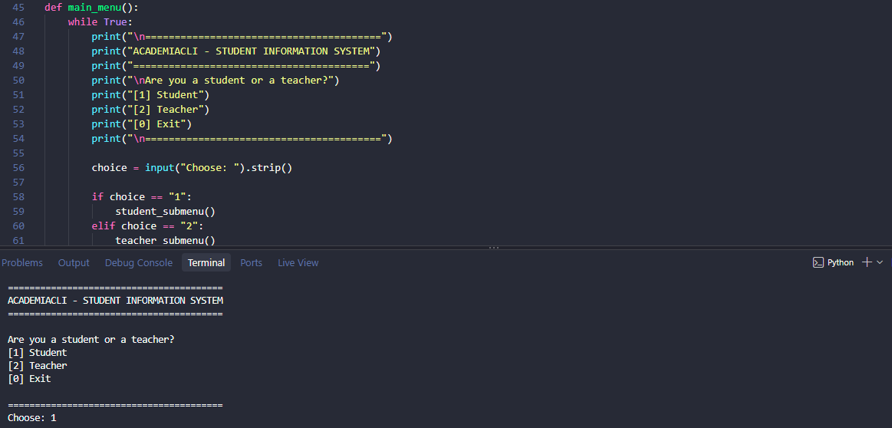
Snippet 1 – Adding Student Information
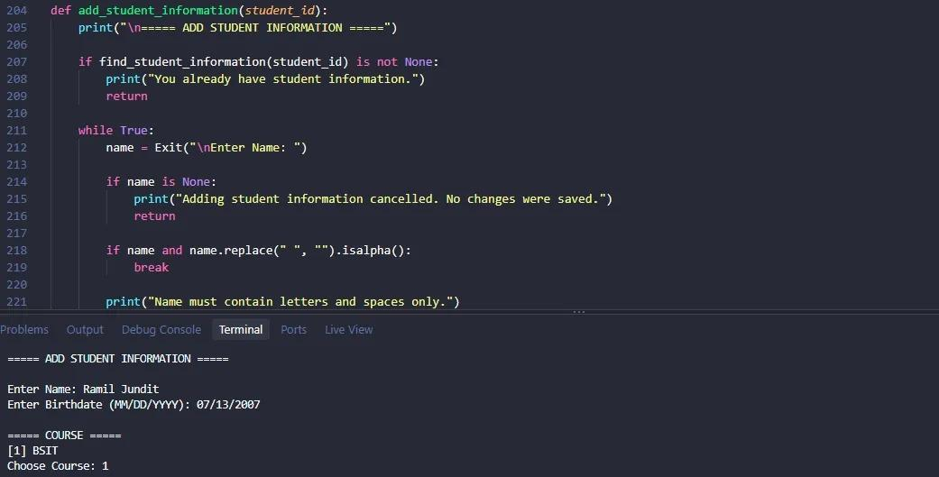
Related Objective: Specific Objective 1 - To develop a function that allows students to input, record, and store basic student details (Student ID, name, birthdate, course, year level, and section) into structured digital storage, directly addressing the difficulty in organizing basic student information.
Purpose: This function allows a logged-in student to enter and store their basic information.

def add_student_information(student_id):
print("\n===== ADD STUDENT INFORMATION =====")

if find_student_information(student_id) is not None:
print("You already have student information.")
return

while True:
name = Exit("\nEnter Name: ")

if name is None:
print("Adding student information cancelled. No changes were saved.")
return

if name and name.replace(" ", "").isalpha():
break

print("Name must contain letters and spaces only.")

while True:
birthdate = Exit("Enter Birthdate (MM/DD/YYYY): ")

if birthdate is None:
print("Adding student information cancelled. No changes were saved.")
return

try:
datetime.strptime(birthdate, "%m/%d/%Y")
break
except ValueError:
print("Invalid birthdate. Use MM/DD/YYYY (example: 09/15/2007).")

while True:
print("\n===== COURSE =====")
print("[1] BSIT")

choice = Exit("Choose Course: ")

if choice is None:
print("Adding student information cancelled. No changes were saved.")
return

if choice == "1":
course = "BSIT"
break

print("Invalid choice. Enter 1.")

while True:
print("\n===== YEAR LEVEL =====")
print("[1] 1st Year")

choice = Exit("Choose Year Level: ")

if choice is None:
print("Adding student information cancelled. No changes were saved.")
return

if choice == "1":
year = "1st Year"
break

print("Invalid choice. Enter 1.")

while True:
print("\n===== SECTION =====")

for number, section_name in enumerate(sections, start=1):
print("[" + str(number) + "] " + section_name)

choice = Exit("Choose Section: ")

if choice is None:
print("Adding student information cancelled. No changes were saved.")
return

if choice.isdigit() and 1 <= int(choice) <= len(sections):
section = sections[int(choice) - 1]
break

print("Invalid choice. Enter a number from the section list.")

students[course].append({
"id": student_id,
"name": name,
"birthdate": birthdate,
"course": course,
"year": year,
"section": section
})

print("\nStudent information added successfully!")

Explanation:
This code allows a logged-in student to add their basic student information, including their name, birthdate, course, year level, and section. The program checks whether the student already has an existing record to prevent duplicate entries. It validates each input to ensure that the information entered is in the correct format. If the student enters invalid information or cancels the process, the program responds accordingly. Once all information has been validated, the program creates a dictionary containing the student's ID, name, birthdate, course, year level, and section. The record is then stored in the appropriate course list within the students dictionary. Finally, the program displays a success message to confirm that the information has been added.
This function supports Specific Objective 1: To develop a function that allows students to input, record, and store basic student details (Student ID, name, birthdate, course, year level, and section) into structured digital storage, directly addressing the difficulty in organizing basic student information.

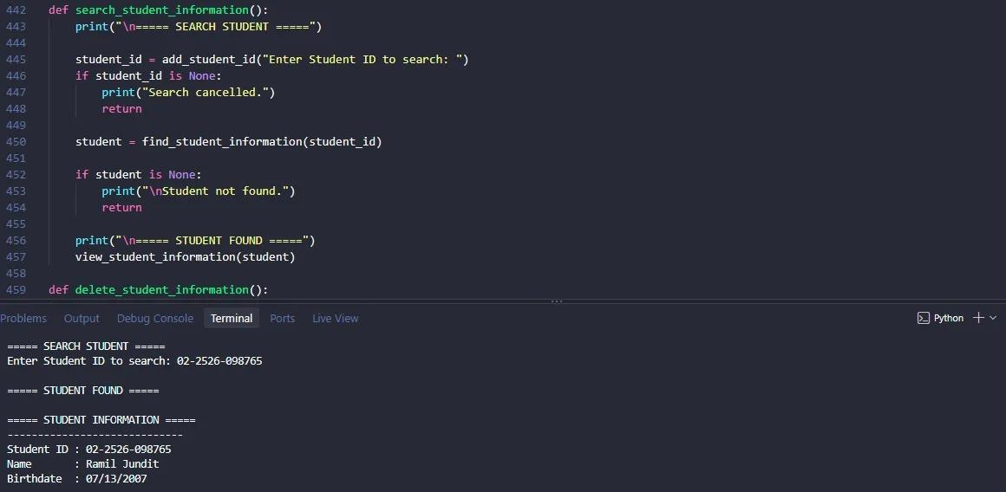
Snippet 2 – Searching for a Student

Related Objective: Specific Objective 2 - To develop a function that allows students to input, record, and store basic student details (Student ID, name, birthdate, course, year level, and section) into structured digital storage, directly addressing the difficulty in organizing basic student information.
Purpose: This function allows a teacher/instructor to search for a specific student record.

def search_student_information():
print("\n===== SEARCH STUDENT =====")

student_id = add_student_id("Enter Student ID to search: ")
if student_id is None:
print("Search cancelled.")
return

student = find_student_information(student_id)

if student is None:
print("\nStudent not found.")
return

print("\n===== STUDENT FOUND =====")
view_student_information(student)

Explanation:
This function allows teachers or instructors to search for a student's information using the Student ID. First, the program displays the search menu and asks the user to enter the Student ID through the add_student_id() function. If the search is cancelled, the program displays a cancellation message and stops. Otherwise, the entered Student ID is passed to the find_student_information() function to check whether a matching student record exists. If no matching record is found, the program displays “Student not found” and stops the search. If a matching record is found, the program displays “Student Found” and calls the view_student_information() function to show the student's information. This function supports Specific Objective 2: To implement a search function that enables instructors to quickly search for and retrieve specific student records using their Student ID, directly addressing the additional time required for searching and accessing records.

Snippet 3 – Updating Student Information
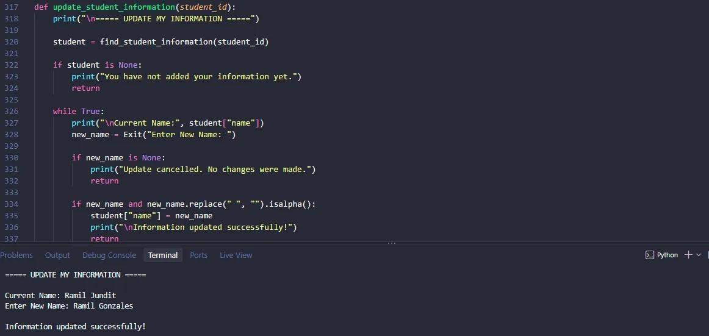
Related Objective: Specific Objective 3 – To provide functions that allow students to update their names and enable instructors to manage records by deleting unwanted entries using Student IDs, directly addressing the difficulty in updating and managing student information.
Purpose: This function allows a student to update their name in the student record.

def update_student_information(student_id):
print("\n===== UPDATE MY INFORMATION =====")

student = find_student_information(student_id)

if student is None:
print("You have not added your information yet.")
return

while True:
print("\nCurrent Name:", student["name"])
new_name = Exit("Enter New Name: ")

if new_name is None:
print("Update cancelled. No changes were made.")
return

if new_name and new_name.replace(" ", "").isalpha():
student["name"] = new_name
print("\nInformation updated successfully!")
return

print("Name must contain letters and spaces only.")

Explanation:
This code allows a student to update their name in their existing student record. First, the program uses the find_student_information() function to locate the student's record using their Student ID. If no record is found, the program displays a message stating that the student has not added their information yet, and the process stops. If a record exists, the program displays the student's current name and asks them to enter a new name. The program checks whether the new name contains only letters and spaces. If the input is invalid, the program asks the student to enter a valid name again. If the student cancels the process, no changes are made. Once a valid name is entered, the program updates the "name" value in the existing student dictionary and displays a success message. This function supports Specific Objective 3: To provide functions that allow students to update their names and enable instructors to manage records by deleting unwanted entries using Student IDs, directly addressing the difficulty in updating and managing student information.

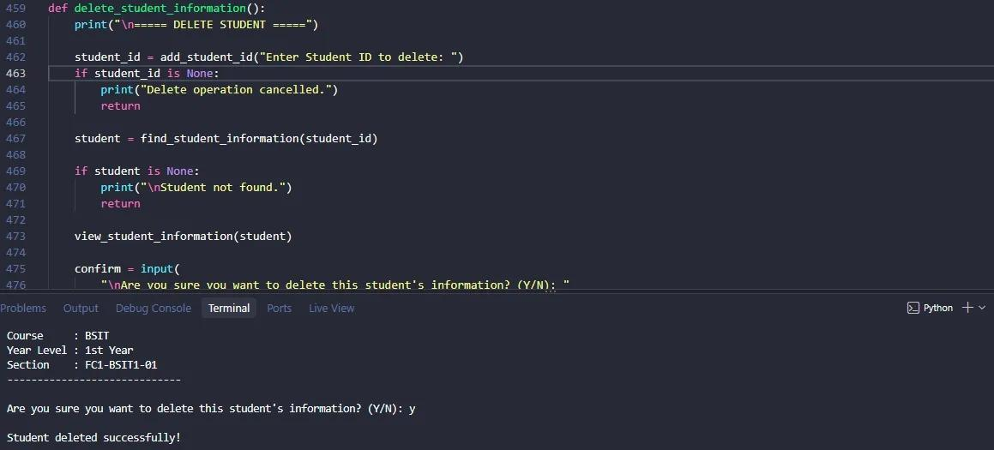
Snippet 4 – Deleting Student Information

Related Objective: Specific Objective 3 – To provide functions that allow students to update their names and enable instructors to manage records by deleting unwanted entries using Student IDs, directly addressing the difficulty in updating and managing student information.
Purpose: This function allows teachers/instructors to find a student record and delete it after confirmation.

def delete_student_information():
print("\n===== DELETE STUDENT =====")

student_id = add_student_id("Enter Student ID to delete: ")
if student_id is None:
print("Delete operation cancelled.")
return

student = find_student_information(student_id)
if student is None:
print("\nStudent not found.")
return

view_student_information(student)

confirm = input(
"\nAre you sure you want to delete this student's information? (Y/N): "
).strip().upper()

if confirm == "Y":
students[student["course"]].remove(student)
print("\nStudent deleted successfully!")
else:
print("\nDeletion cancelled.")

Explanation:
This code allows teachers or instructors to delete a student's information using the Student ID. First, the program asks the teacher or instructor to enter the Student ID through the add_student_id() function. If the operation is cancelled, the program displays a cancellation message and stops. Otherwise, the program uses the find_student_information() function to locate the student's record. If no matching record is found, it displays “Student not found” and stops the process. If the record exists, the program displays the student's information using the view_student_information() function and asks for confirmation before deleting it. If the teacher or instructor enters Y, the program removes the student record from the list corresponding to the student's course and displays a success message. If any other response is entered, the deletion is cancelled. This function supports Specific Objective 3: To provide functions that allow students to update their names and enable instructors to manage records by deleting unwanted entries using Student IDs, directly addressing the difficulty in updating and managing student information.

References
- Çelik, K., & Ayaz, A. (2022). Validation of the DeLone and McLean information systems success model: A study on student information systems. Education and Information Technologies, 27(4), 4709–4727.
- Cenezan, J. F., & Gacusan, R. M. (2025). Development of a student support services system through data analytics approach in students’ affairs and services office records management system of Ilocos Sur Polytechnic State College - Main Campus. E-DAWA: An International Multidisciplinary Research Journal, 5(2), 32–41. https://doi.org/10.56901/edawa2025V5I2-03
- Gomathy, C. K., Kumar, A. P., Mahesh, C. V., & Reddy, Y. J. K. (2022). Student information management system. International Journal of Scientific Research in Engineering and Management, 6(3). https://doi.org/10.55041/IJSREM11816
- Riño, J. L., & Daing, C. A. (2022). Challenges in handling student records and characteristics of student information management system in public secondary school in Marilao South District IV Bulacan. Psychology and Education: A Multidisciplinary Journal, 4(1), 105–120. https://doi.org/10.5281/zenodo.7033238

